Hero Banner
AI-Powered Ticketing & Incident Management System
With Intelligent Voice Assistant
Automate Support. Resolve Faster. Reduce Downtime.
👉 [Book a Demo] 👉 [Request a Callback]

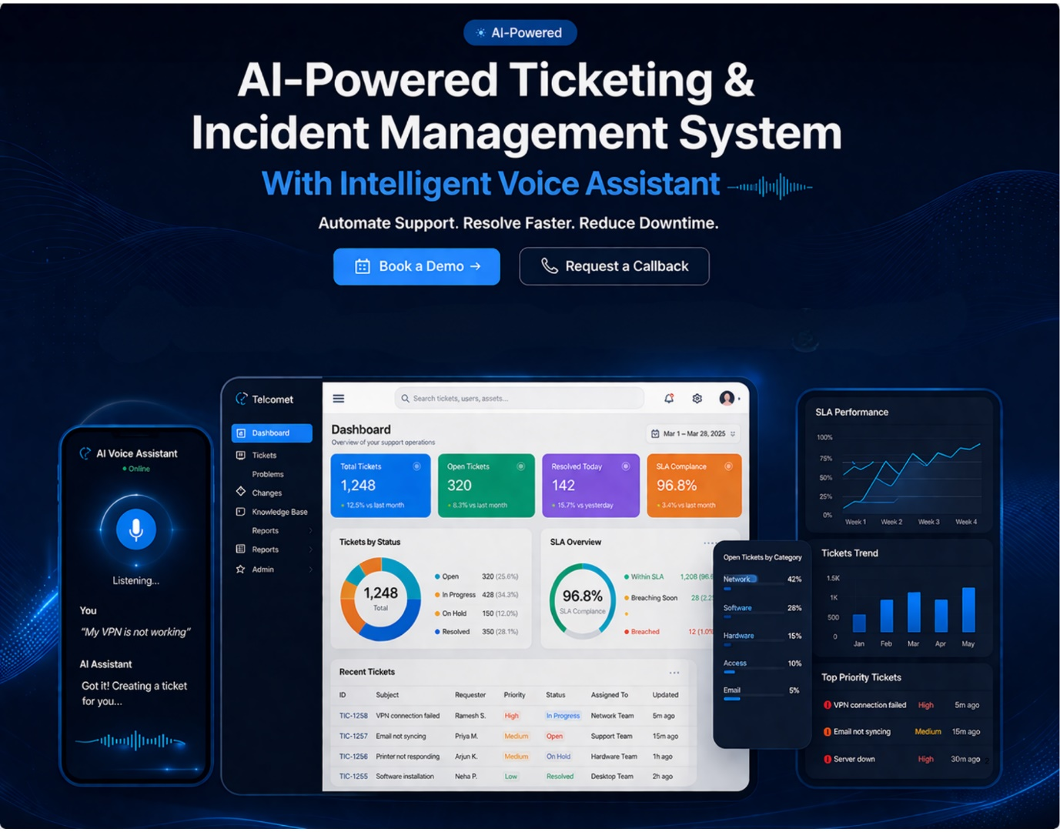

Transform your IT support operations with Telcomet’s AI-driven ticketing platform designed to streamline issue management, improve response times, and enhance user experience.

🚨 Are These Challenges Slowing Down Your IT Operations?
- High volume of support requests across departments
- Manual ticket logging causing delays
- Lack of real-time visibility into ticket status & SLAs
- Multiple communication channels creating confusion
- Slow issue resolution impacting productivity
👉 If yes, you’re not alone — and we’ve built the solution for it.

💡 Introducing Telcomet AI Ticketing System
An intelligent, ITIL-aligned ticketing platform powered by AI Voice Assistant to automate support workflows and accelerate issue resolution.

🔹 Key Capabilities
- AI Voice-based ticket creation
- Automated categorization & assignment
- Incident & service request management
- SLA tracking & escalation
- Real-time dashboards & analytics
- Multi-channel ticket capture

🎤 AI Voice Assistant – Your Competitive Edge
“Speak your issue. Get it resolved.”
Telcomet’s AI Voice Assistant acts as a Virtual L0 Support Layer, enabling users to interact naturally and resolve issues faster.

What It Can Do:
- Create tickets through voice commands
- Provide instant ticket status updates
- Suggest solutions from knowledge base
- Automatically route tickets to the right team

⚙️ Comprehensive Feature Set
🎫 Ticket Management
- Incident & service request handling
- Smart categorization & prioritization
🤖 AI & Automation
- Auto-assignment & routing
- AI-based recommendations
⏱ SLA Management
- SLA definition & tracking
- Automated escalation
📊 Reporting & Analytics
- Real-time dashboards
- Performance insights
🔗 Multi-Channel Support
- Voice, portal, email, chatbot

🔄 How It Works
- User raises request via voice / portal
- AI categorizes & prioritizes the ticket
- Ticket auto-assigned to the right team
- SLA tracking begins
- Issue resolved & closed

📈 Business Impact & ROI
- 40–50% reduction in manual ticket handling
- 30–40% faster issue resolution
- 20–30% reduction in ticket volume (via AI self-service)
- Reduced operational downtime
- Improved IT team productivity
- Enhanced employee experience

🏢 Who Is It For
- Enterprises & Corporate IT Teams
- Managed Service Providers (MSPs)
- IT Helpdesks & Support Centers
- Multi-location organizations

⚖️ Why Telcomet
Feature | Telcomet | Traditional Tools
AI Voice Assistant | ✅ | ❌
AI-First Approach | ✅ | Limited
Deployment Speed | Fast | Moderate/Slow
Cost Efficiency | High | Medium/High

🚀 Experience Intelligent Support Automation
Move beyond traditional ticketing systems and embrace AI-driven support operations.
👉 Book a Live Demo
👉 See AI Voice Assistant in Action

📞 Contact Us
Telcomet Global Solutions Pvt Ltd
📧 praveen@telcomet.com
📞 +91 80088 88135
🌐 www.telcomet.com

